*Группа:* 5_16JavaST_EPAM_Evening

*Автор:* Гапеенко Владислав

*Тема:* Система HR

INSERT INTO applicant (email, password, surname, name, secondName, work_phone, home_phone, mob_phone, contact_phone, skype, birth_date, millatry, role)

VALUES ('zhenaVMinsk@mail.ru', 'daskiu2i3141', 'Захаева', 'Евгения', 'Петровна', '4568923', '4345798', '4334459', 'mobPhone', 'zhenazhena', '1992-02-02', 'not bound', 'applicant');

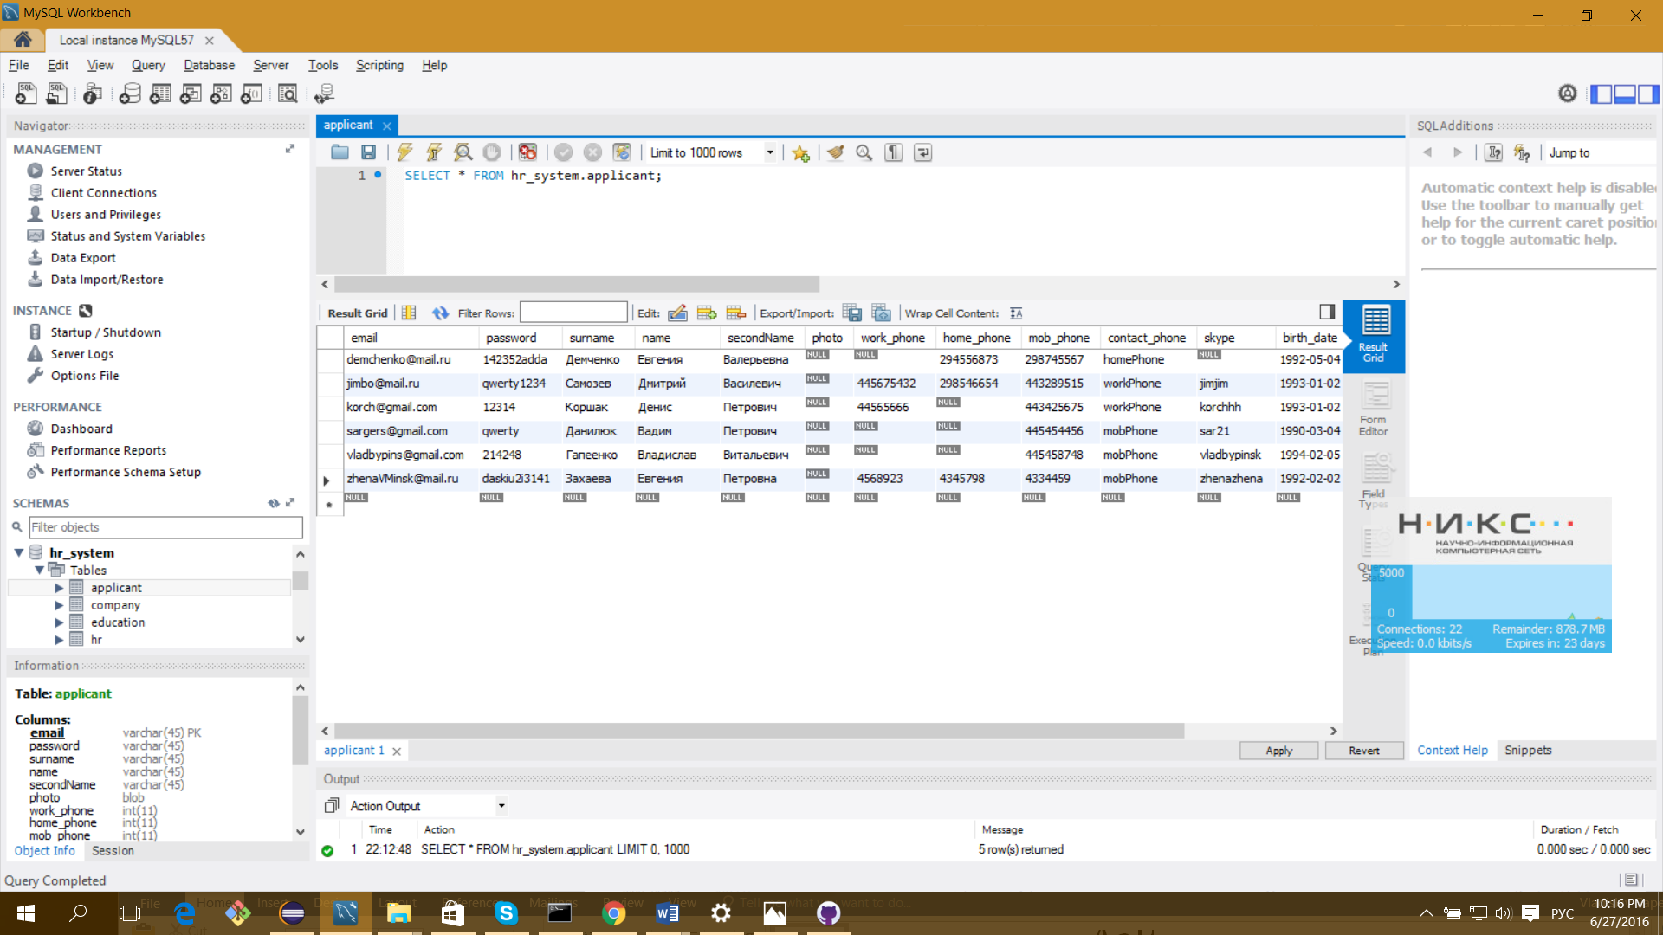

UPDATE applicant SET email='zhenaVminsk@mail.ru', password='daskiu2i3141134', skype='zhenazhen' WHERE email='zhenaVMinsk@mail.ru';

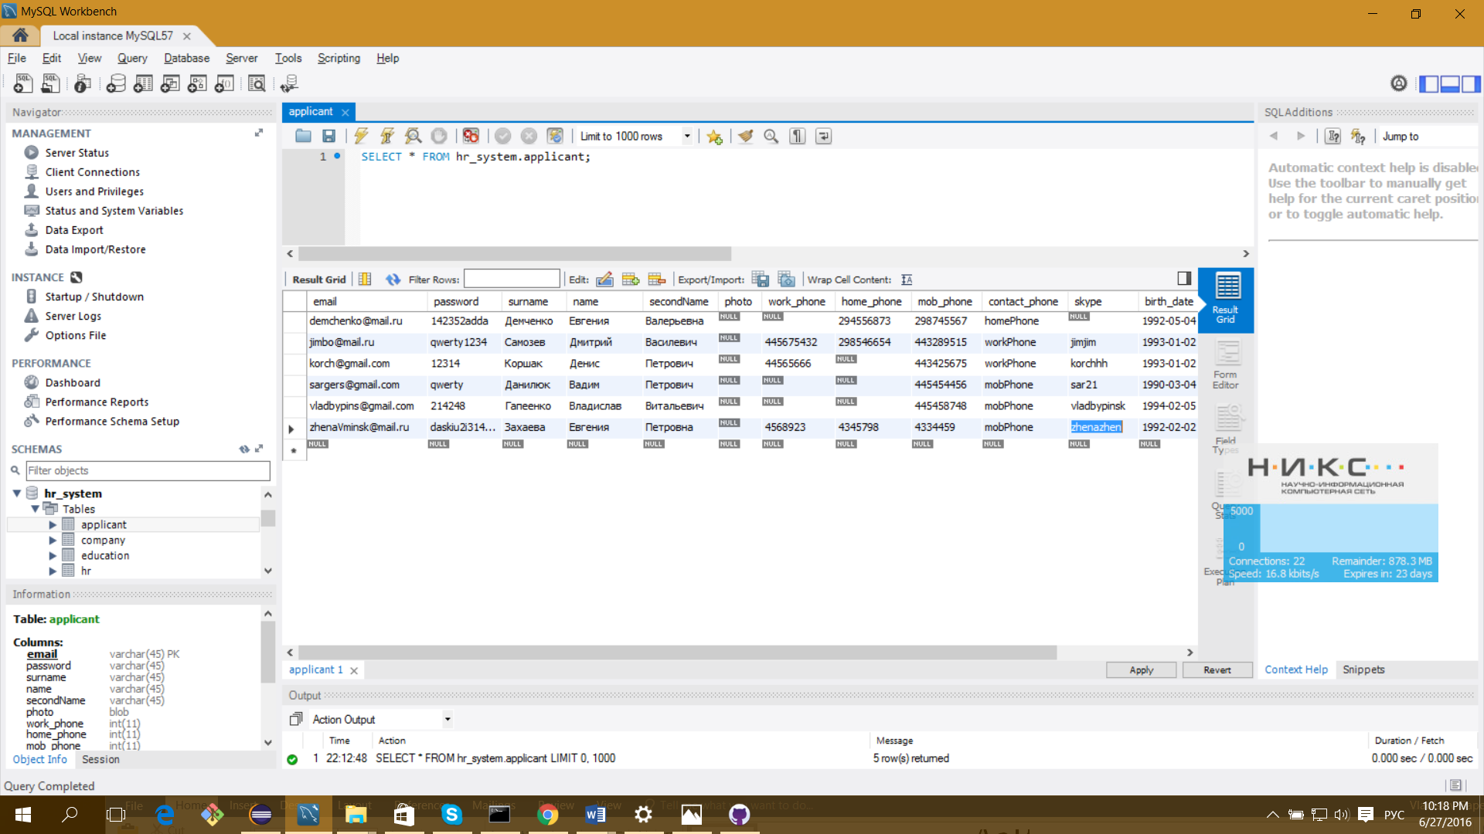

SELECT email FROM applicant WHERE email='jimbo@mail.ru' and password='qwerty1234'

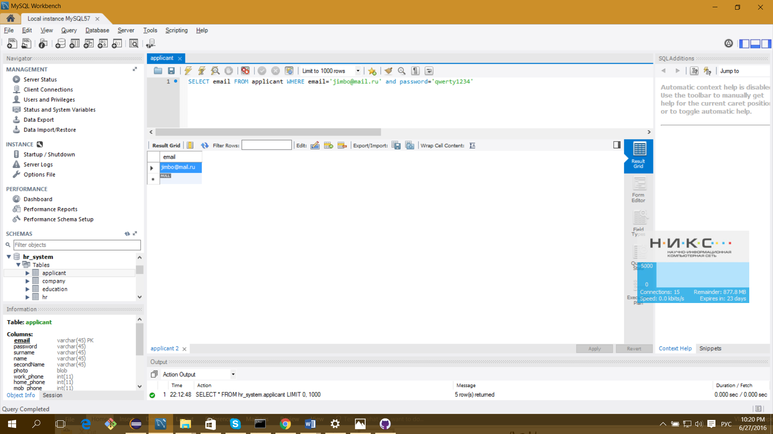

DELETE FROM applicant WHERE [email=zhenaVminsk@mail.ru](mailto:email=zhenaVminsk@mail.ru);

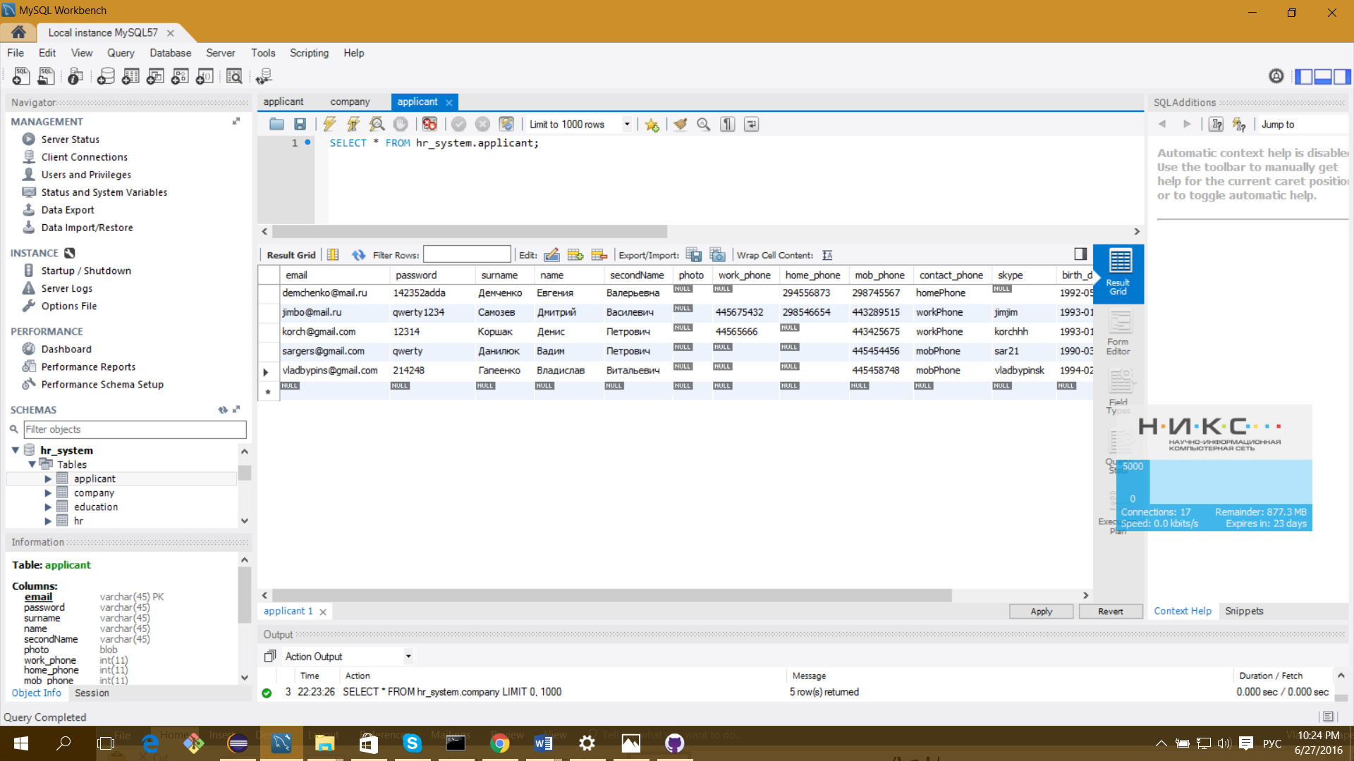

INSERT INTO `hr_system`.`company` (`company_login`, `password`, `name`, `web_site`, `city`, `role`) VALUES ('jimson', 'jjjsferq', 'Jsinam', 'jsin.ru', 'Пинск', 'company');

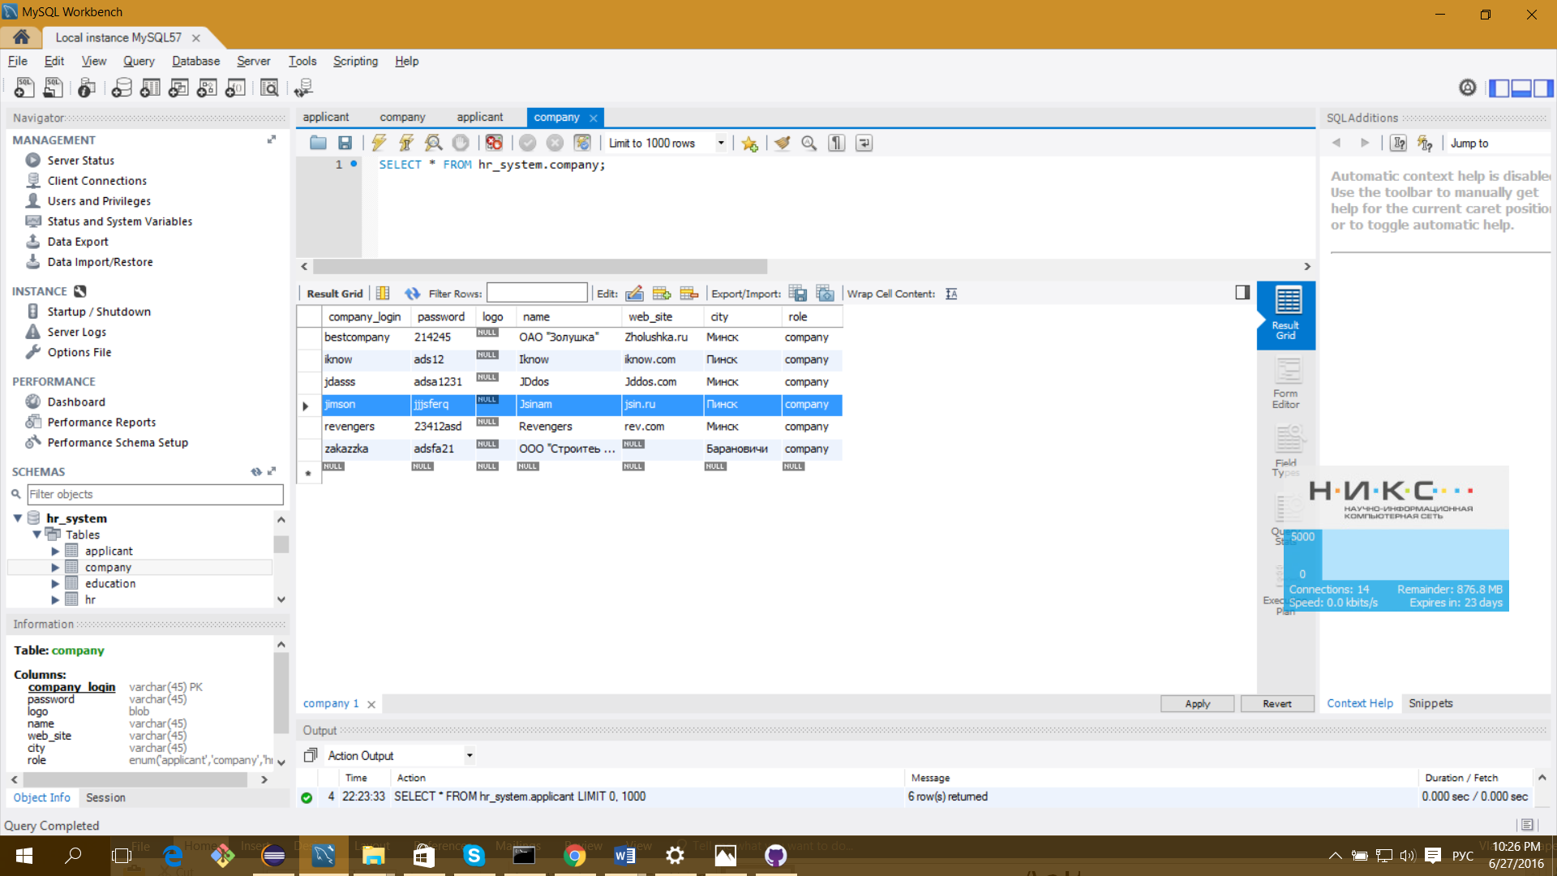

UPDATE `hr_system`.`company` SET `name`='Jsinamas', `city`='Логишин' WHERE `company_login`='jimson';

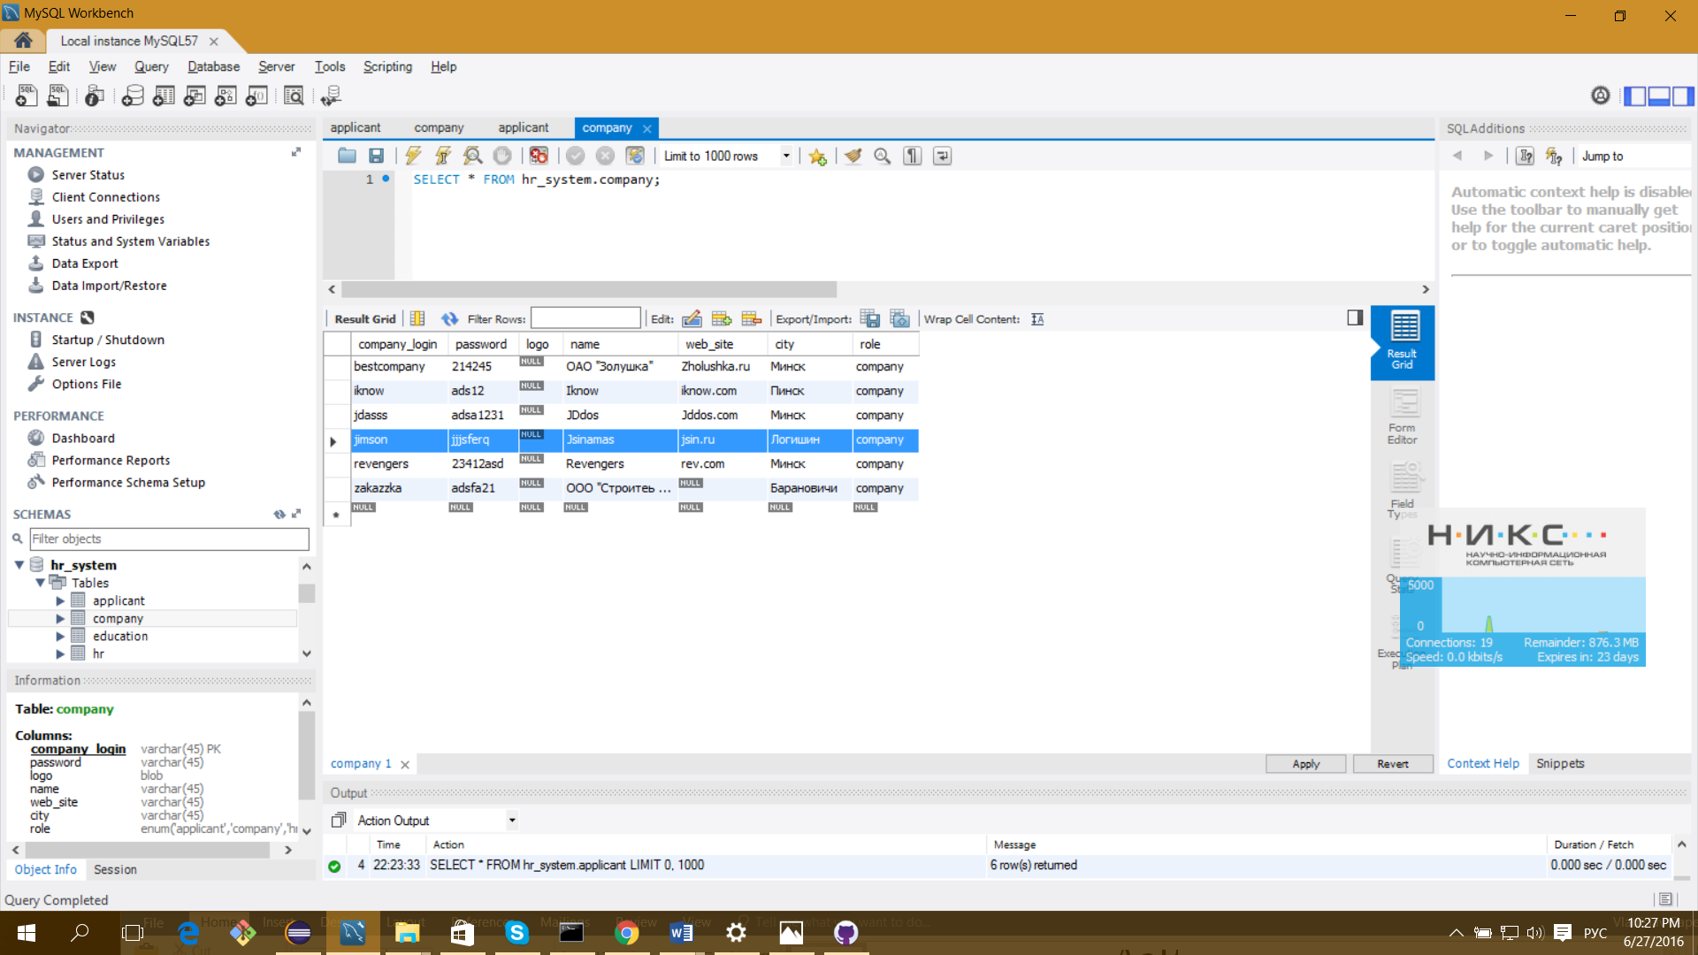

SELECT company_login FROM company WHERE company_login='jimson' and password='jjjsferq'

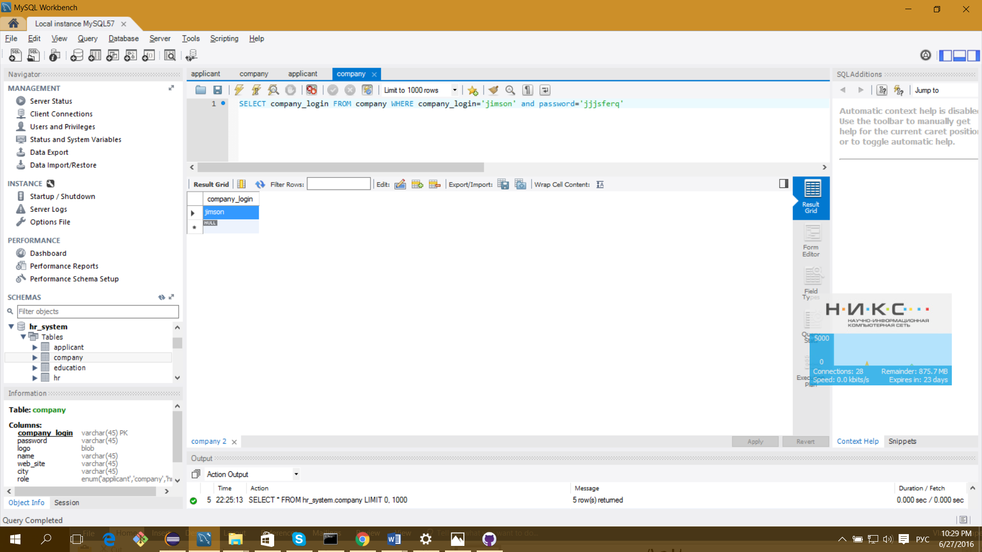

SELECT name

FROM company

WHERE city="Минск"

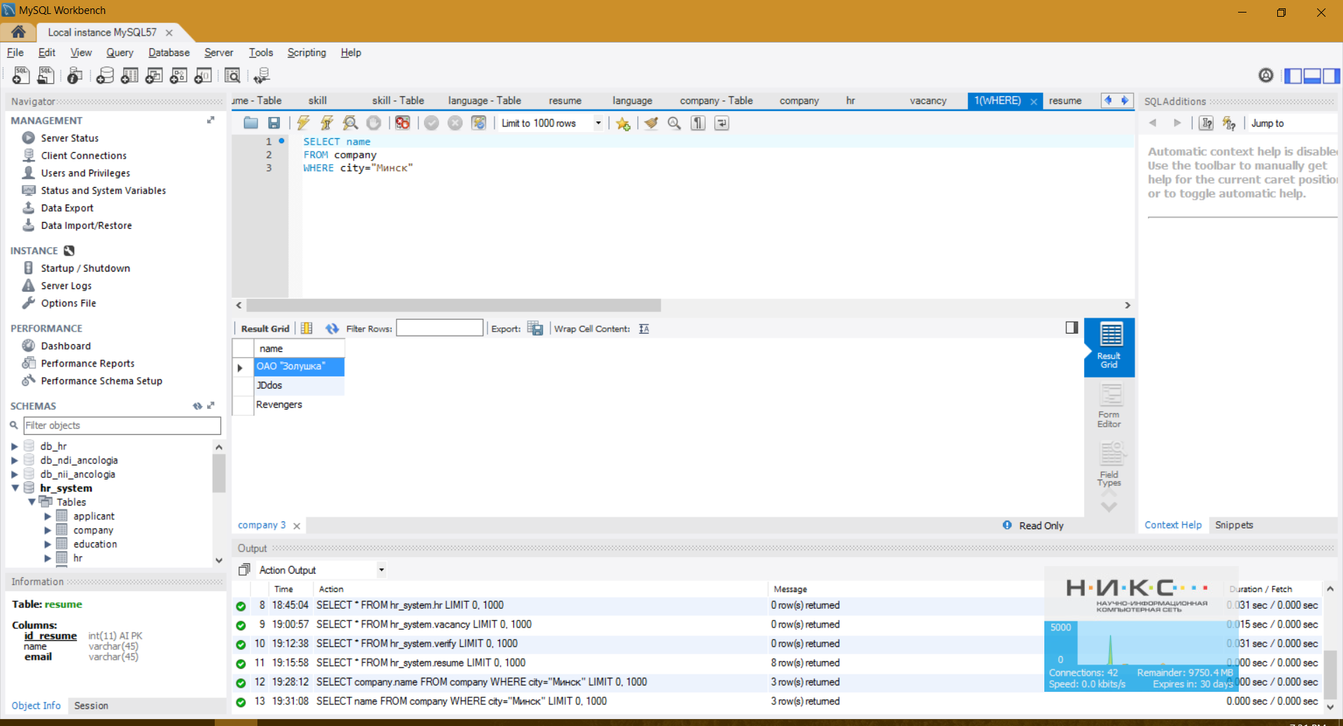

DELETE FROM `hr_system`.`company` WHERE `company_login`='jimson';

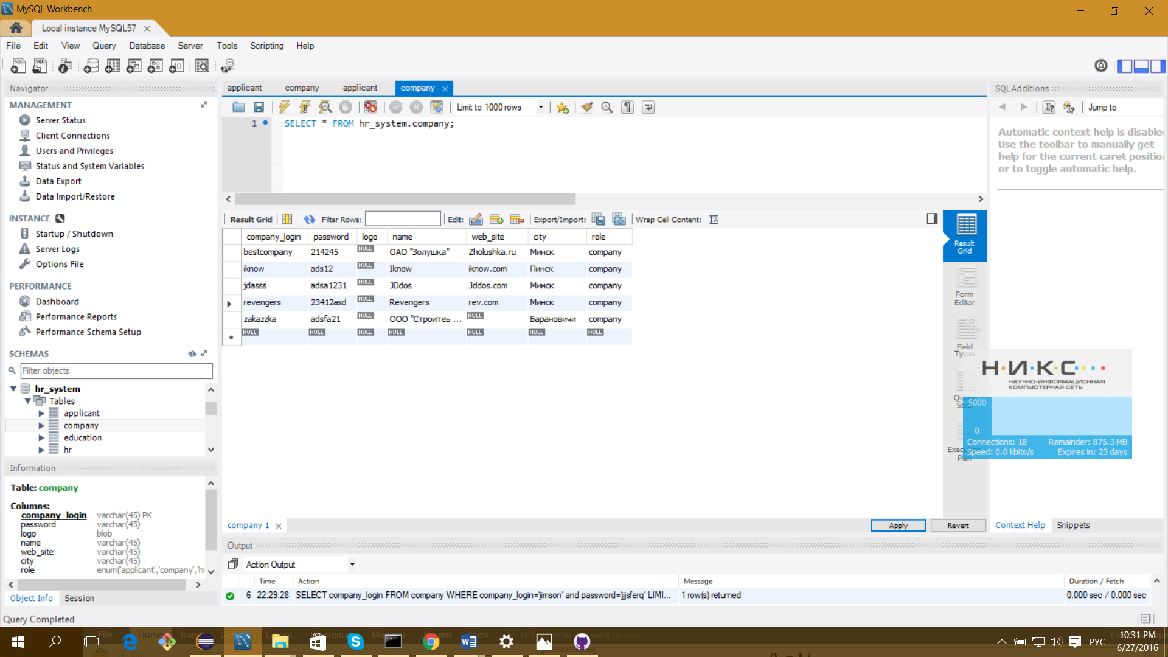

INSERT INTO `hr_system`.`education` (`institution`, `faculty`, `department`, `education`, `course`, `grad_year`, `postgraduate`, `id_resume`) VALUES ('БНТУ', 'ФИТР', 'повт', 'higher', '1', 2015, 'assigned', '3');

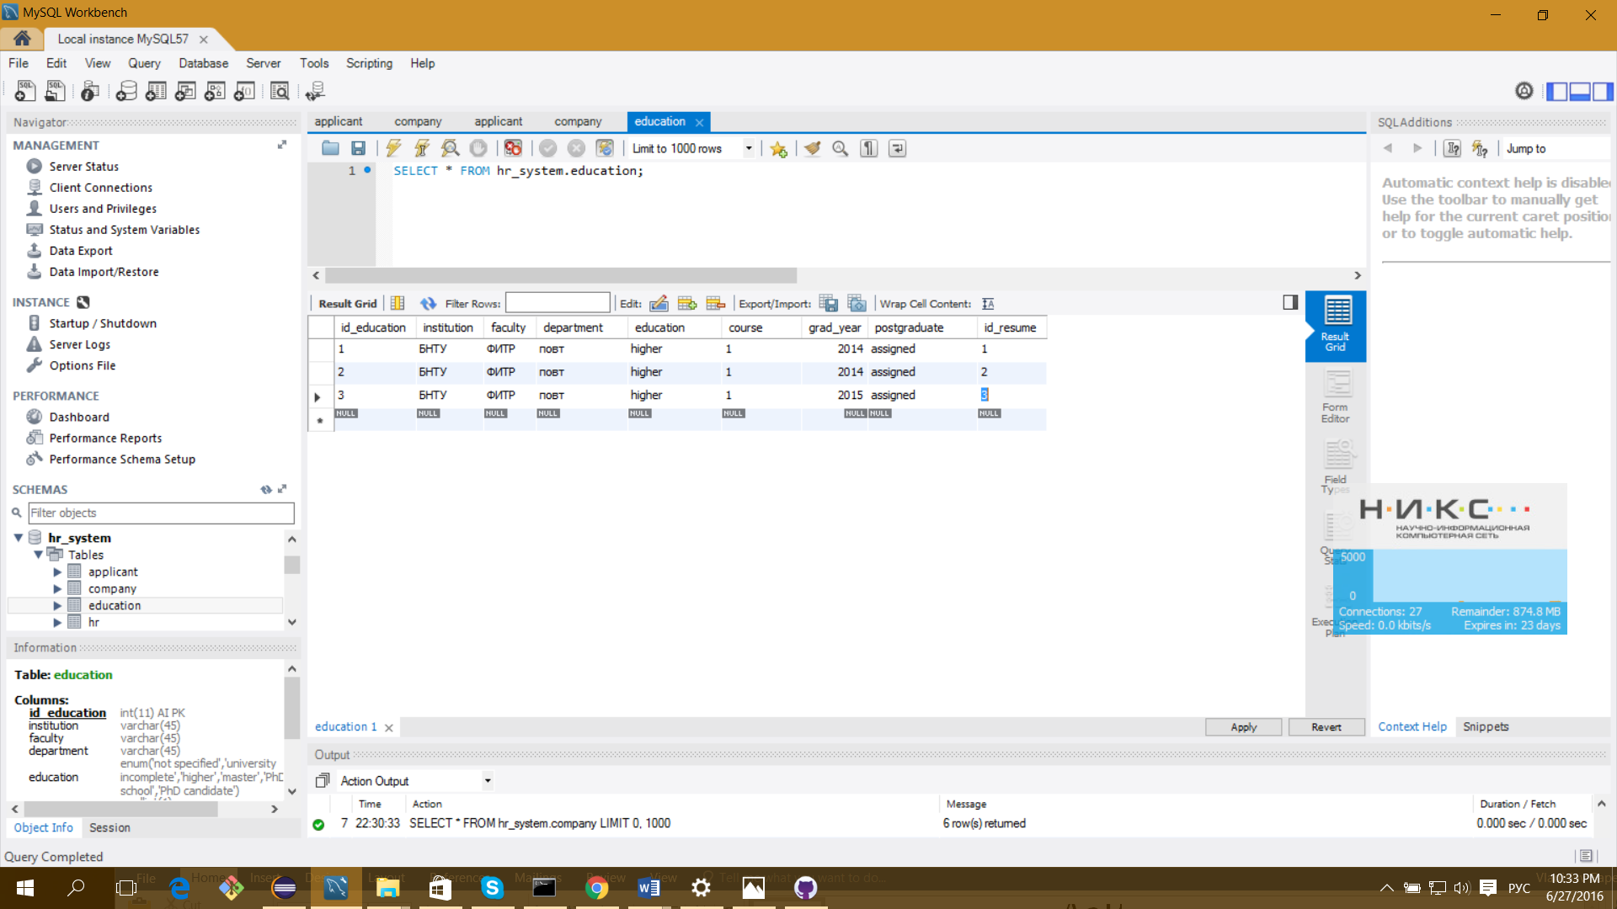

UPDATE `hr_system`.`education` SET `institution`='БГУ', `faculty`='ФТНК', `department`='повтар', `course`='4' WHERE `id_education`='4';

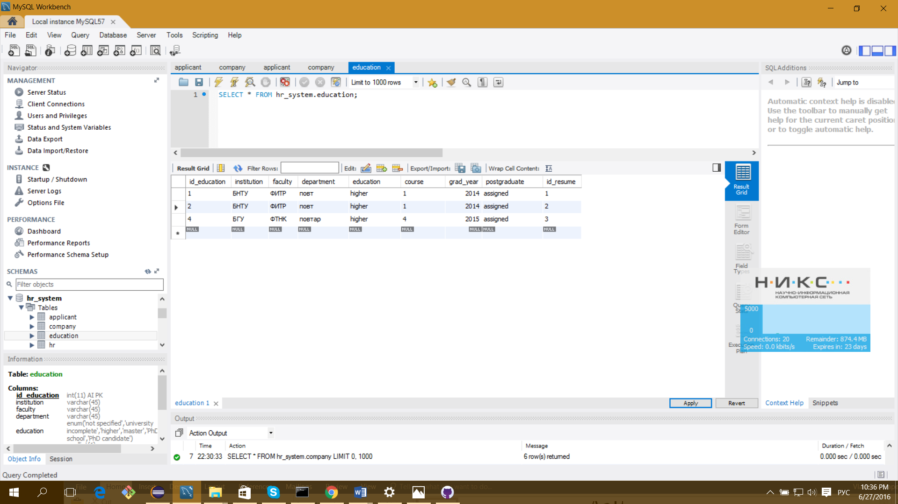

DELETE FROM `hr_system`.`education` WHERE `id_education`='4';

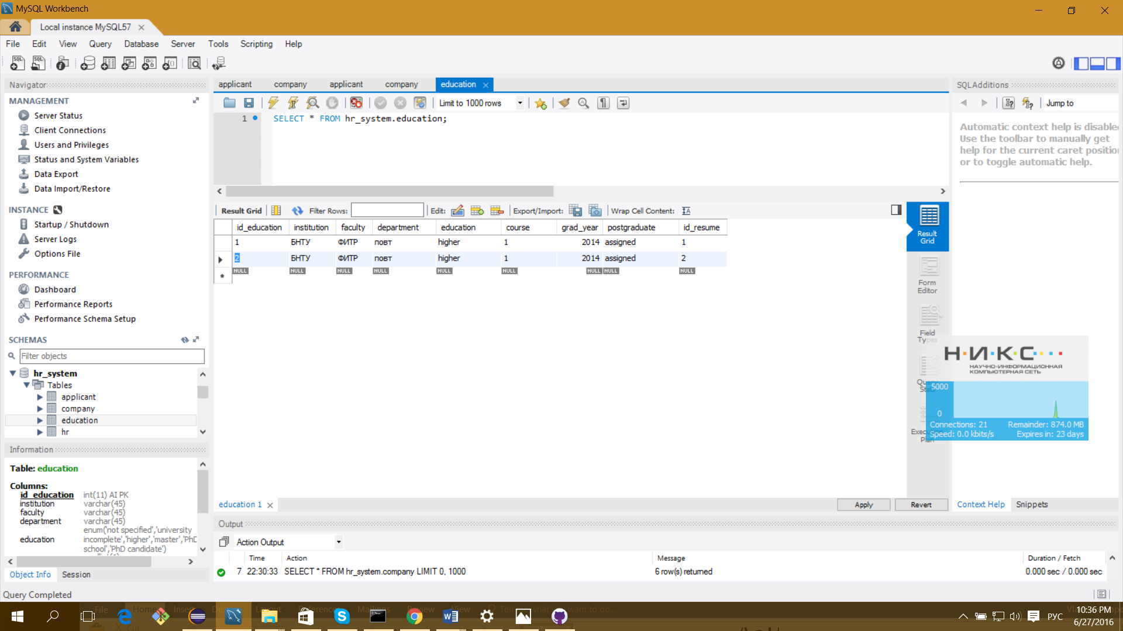

SELECT e.institution, e.institution, e.faculty, e.department, e.education, e.course, e.grad_year, e.postgraduate

FROM resume as r JOIN education as e ON r.id_resume = e.id_resume WHERE r.id_resume=1;

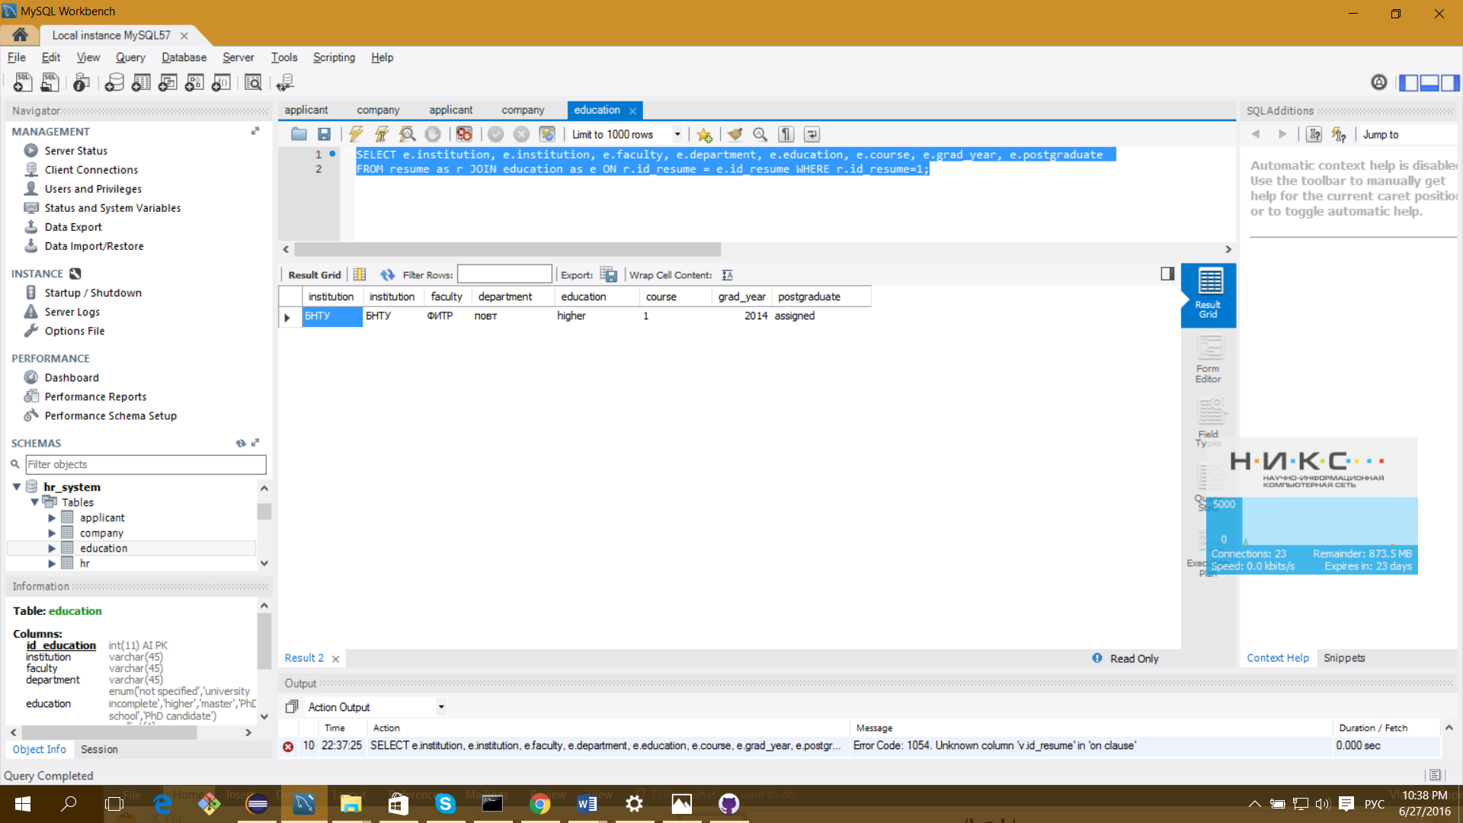

INSERT INTO `hr_system`.`hr` (`email`, `password`, `surname`, `name`, `secondname`, `phone`, `company_login`, `role`) VALUES ('pathi@gmail.com', 'adshfdjhj12312', 'Важнов', 'Михаил', 'Валерьевич', '4872612', 'jdasss', 'hr');

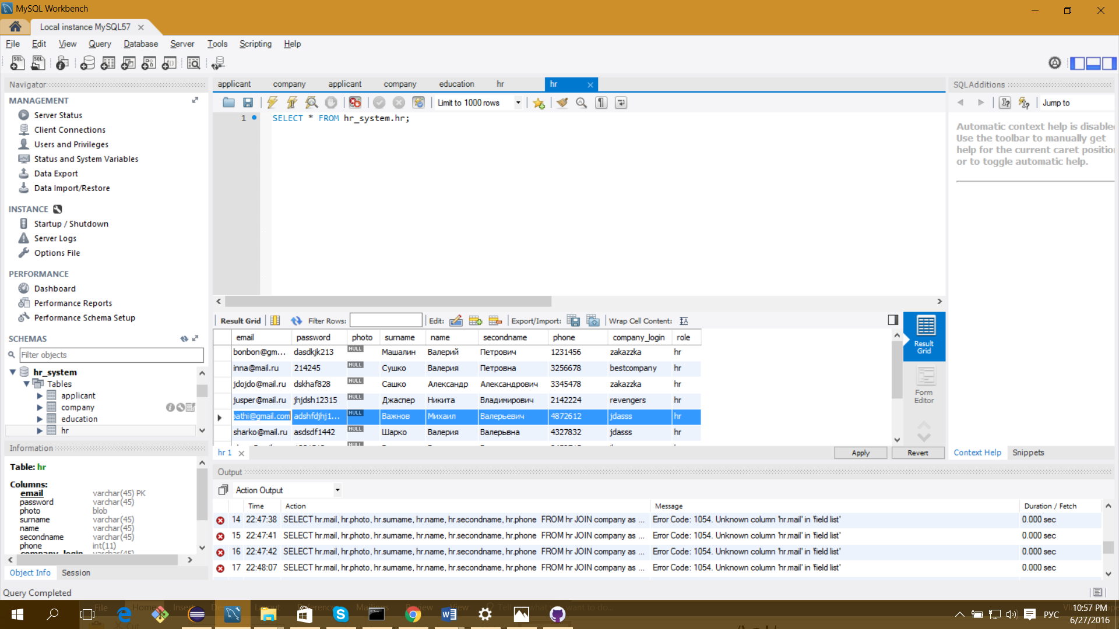

UPDATE `hr_system`.`hr` SET `email`='pathi@mail.ru', `surname`='Важновов' WHERE `email`='pathi@gmail.com';

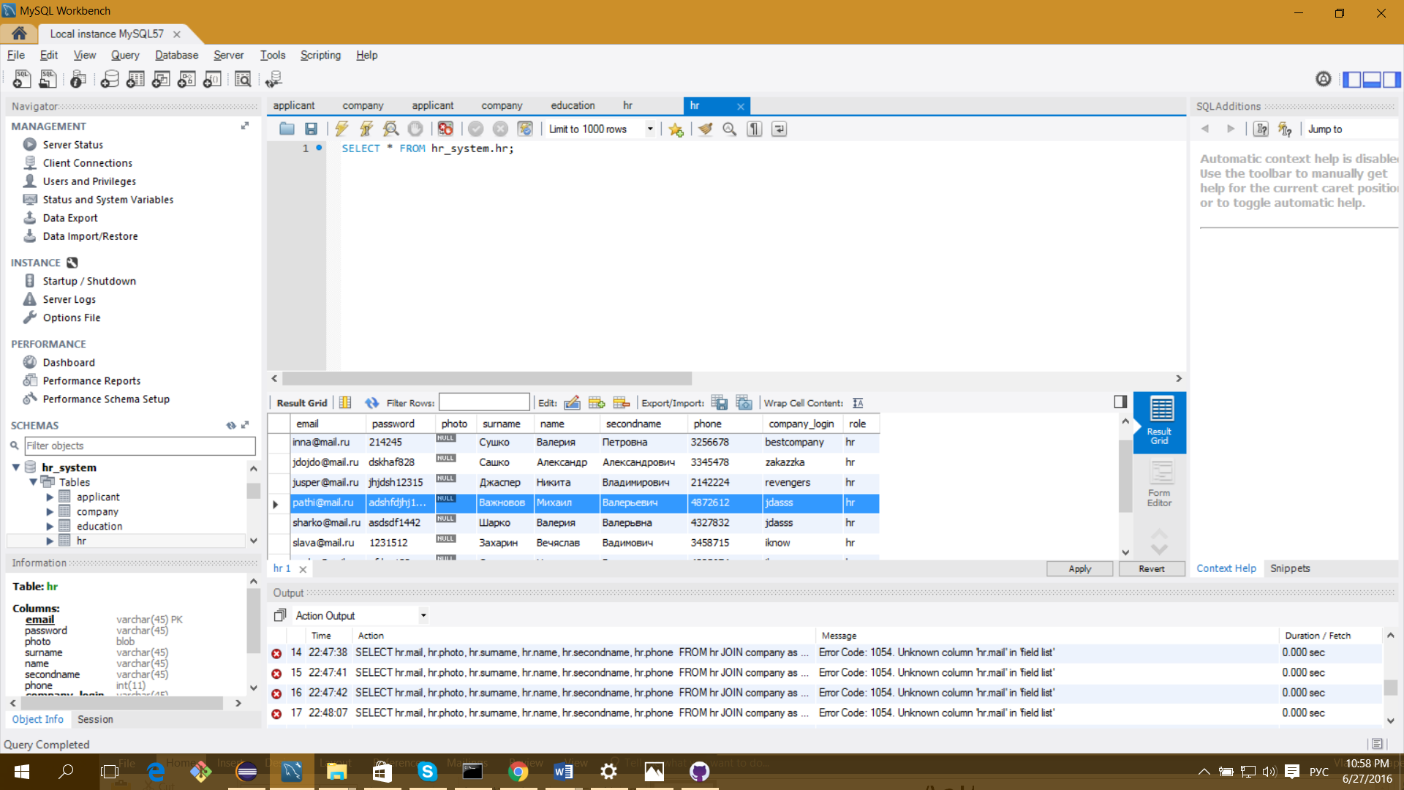

DELETE FROM `hr_system`.`hr` WHERE `email`='pathi@mail.ru';

SELECT email FROM hr WHERE email='jusper@mail.ru' and password='jhjdsh12315'

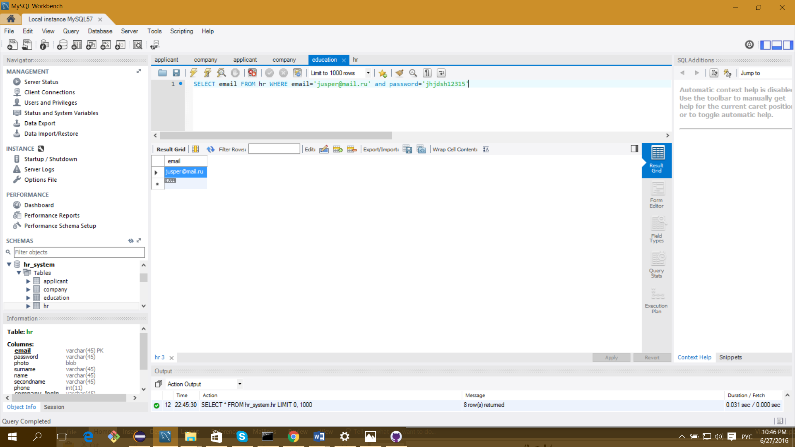

SELECT hr.email, hr.photo, hr.surname, hr.name, hr.secondname, hr.phone

FROM hr JOIN company as c ON hr.company_login = c.company_login

WHERE c.company_login='iknow'

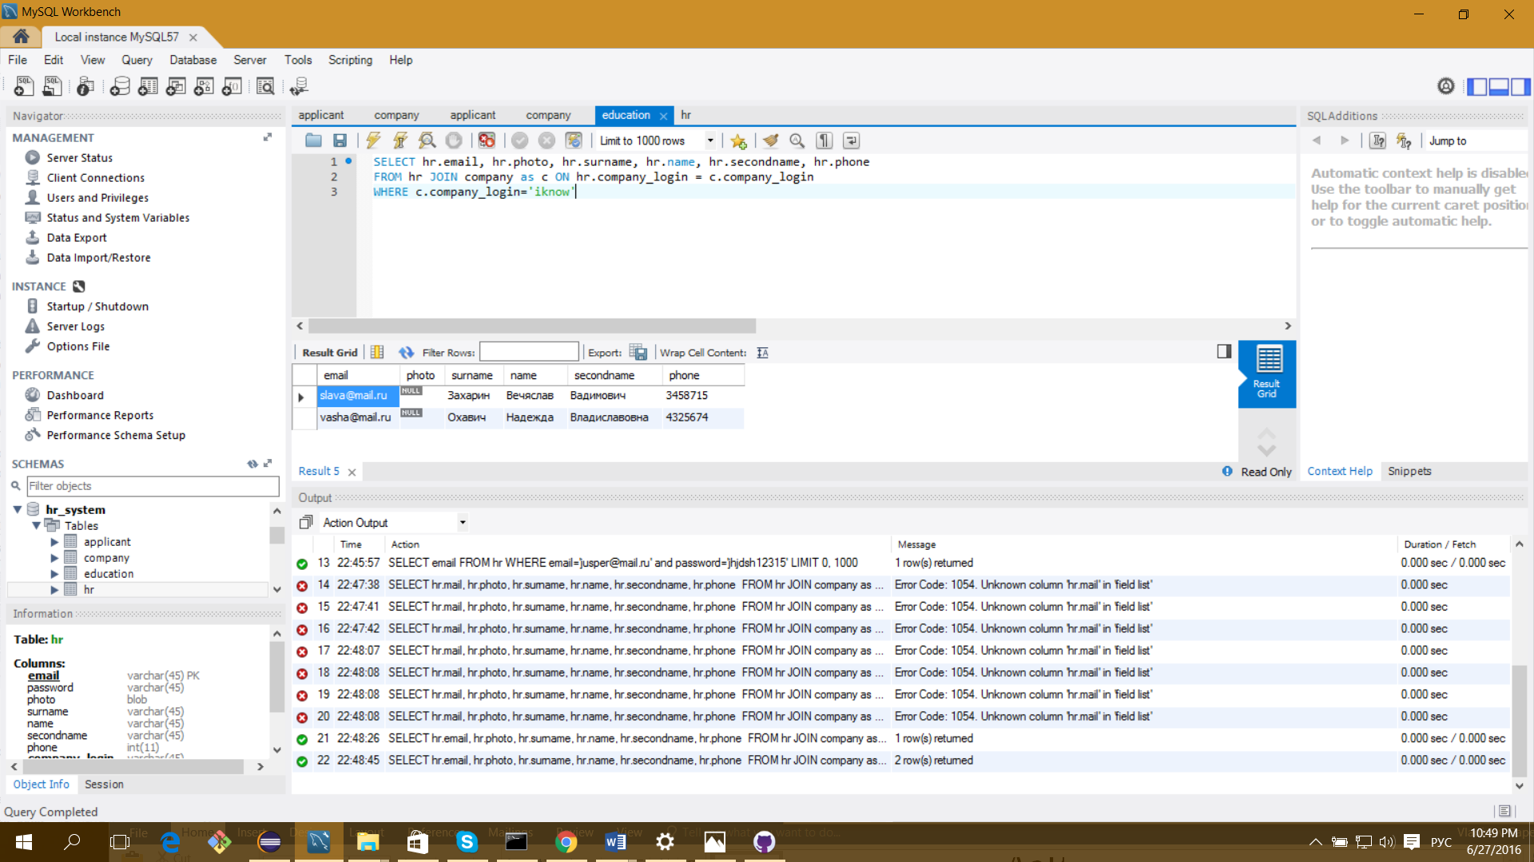

SELECT l.name, l.raiting

FROM resume as r JOIN language as l ON r.id_resume = l.id_resume WHERE r.id_resume=4;

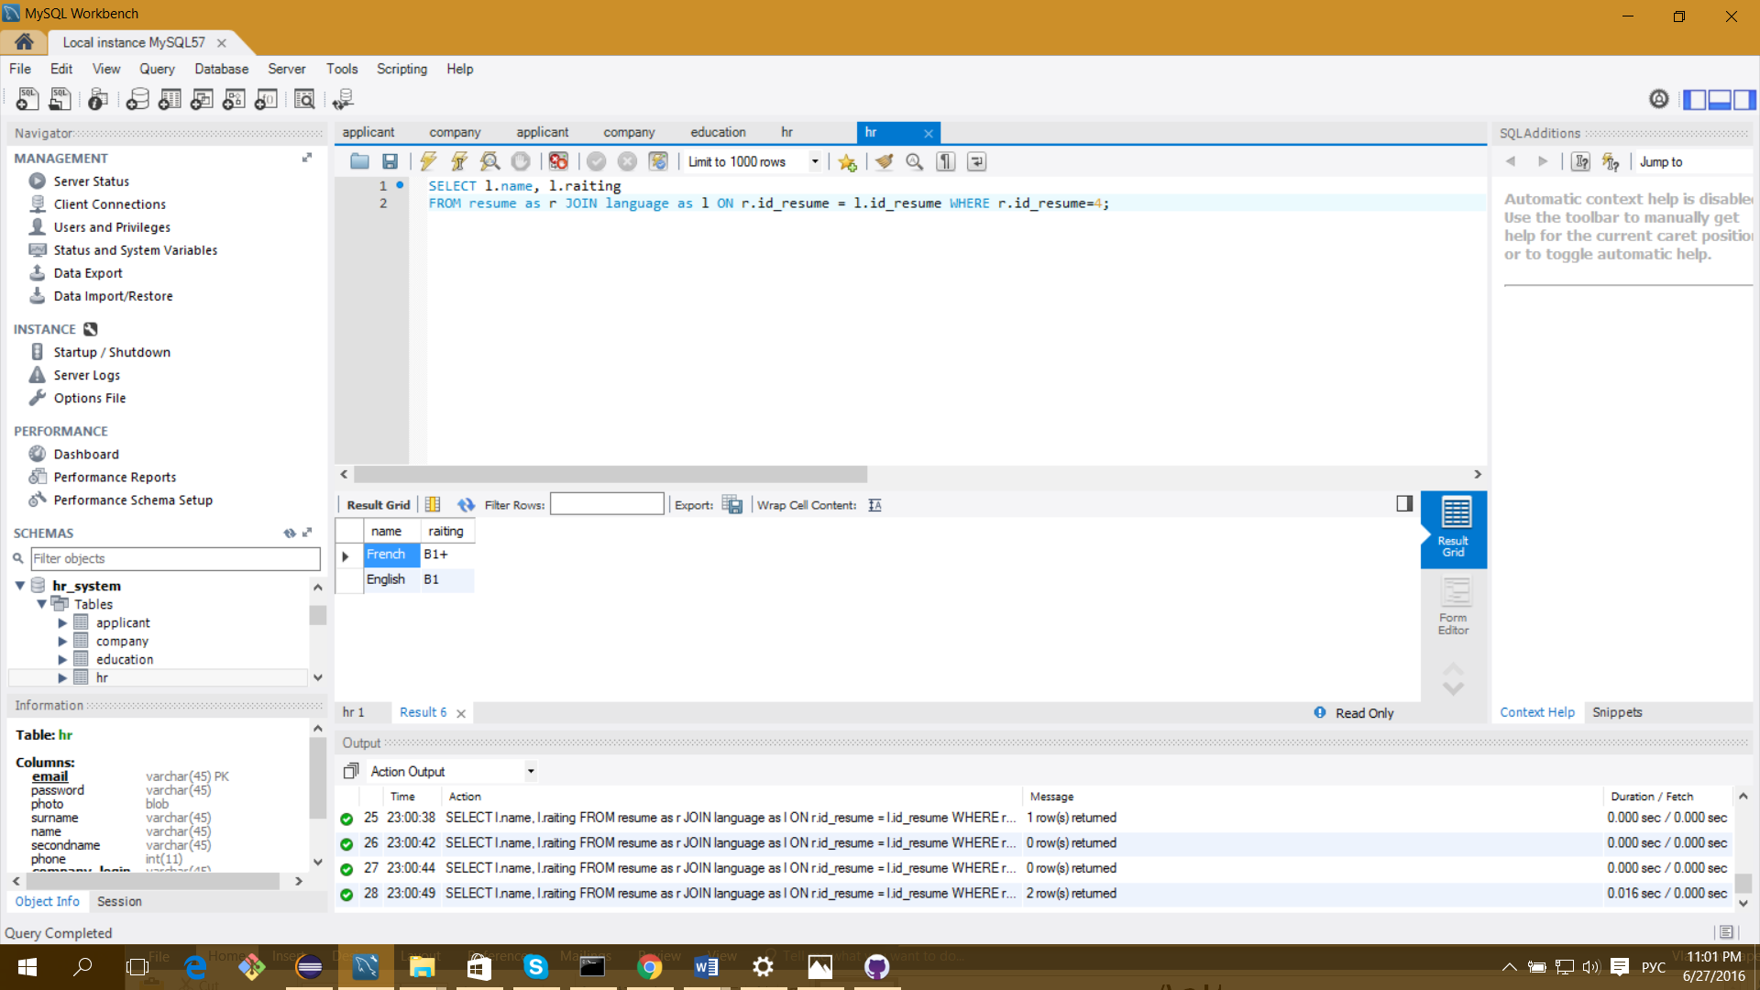

SELECT s.name, s.raiting

FROM resume as r JOIN skill as s ON r.id_resume = s.id_resume WHERE r.id_resume=1

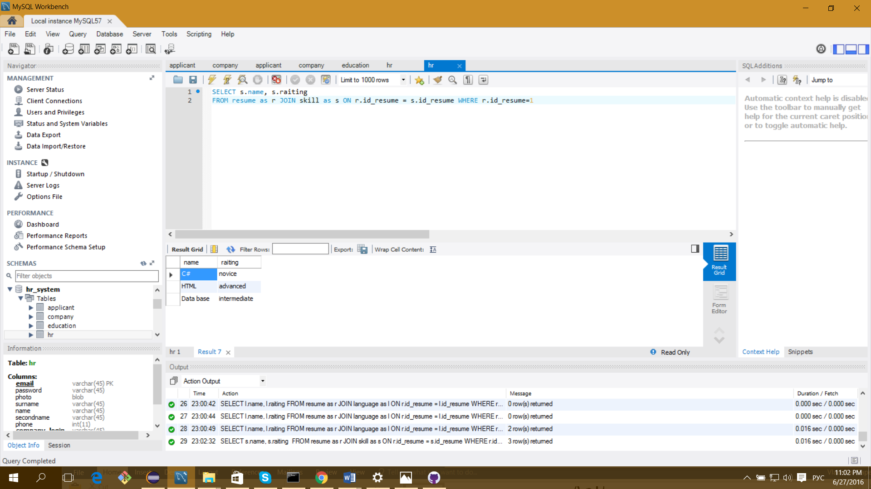

SELECT v.name, salary, currency, publish_date, description, requirements, conditions, employment_type

FROM vacancy as v JOIN hr ON v.email = hr.email JOIN company as c ON hr.company_login= c.company_login

WHERE c.company_login='iknow'

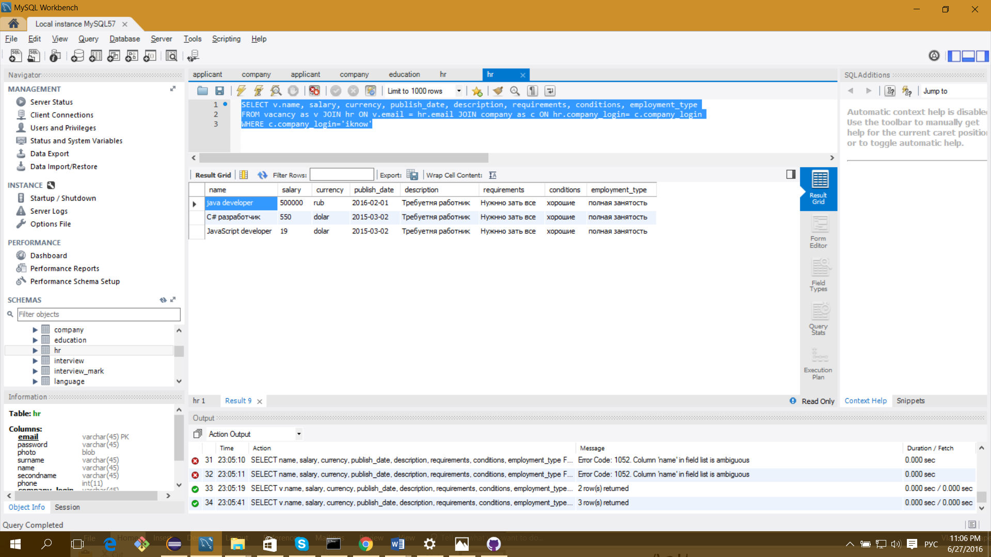

SELECT v.name, salary, currency, publish_date, description, requirements, conditions, employment_type

FROM vacancy as v JOIN hr ON v.email = hr.email WHERE hr.email='slava@mail.ru'

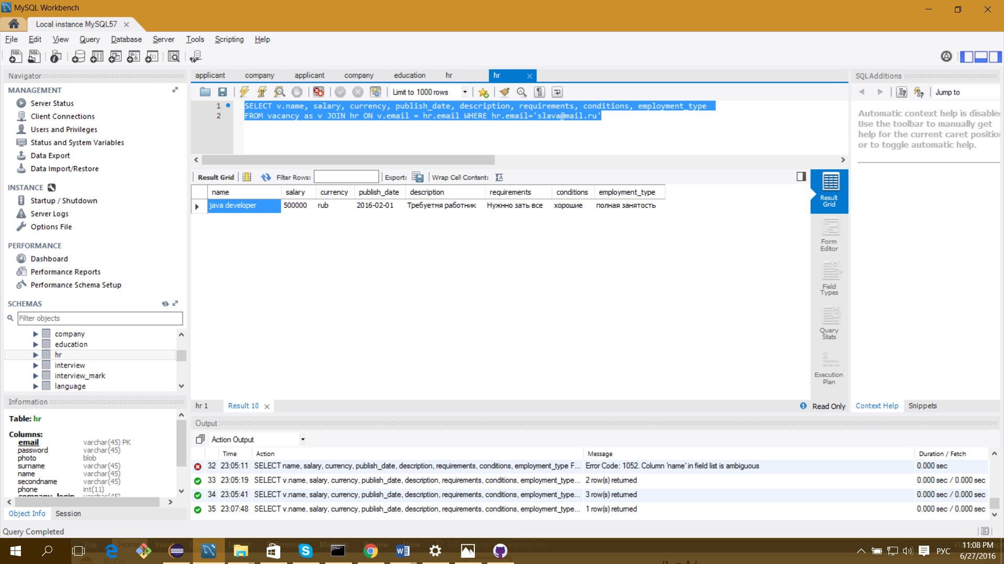

SELECT name, salary, currency, publish_date, description, requirements, conditions, employment_type

FROM vacancy

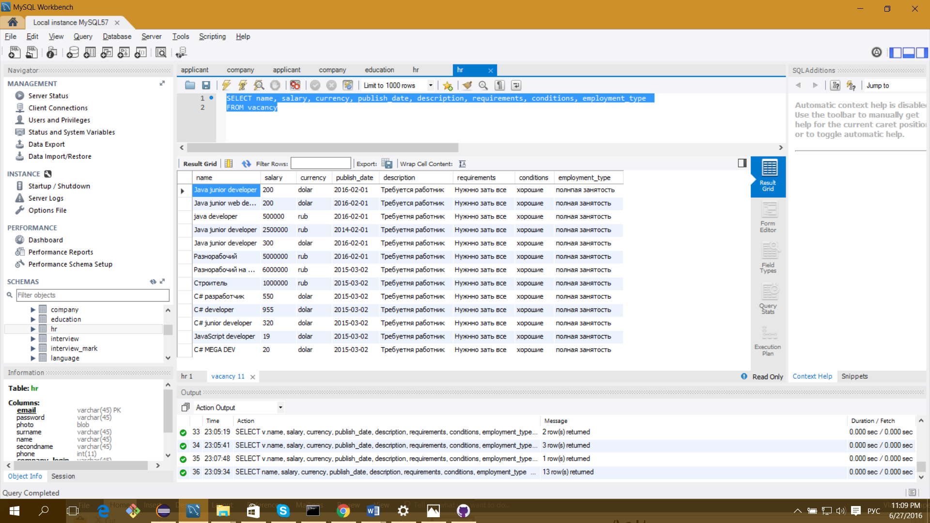

SELECT name, salary, currency, publish_date, description, requirements, conditions, employment_type

FROM vacancy WHERE name LIKE "%Java%"

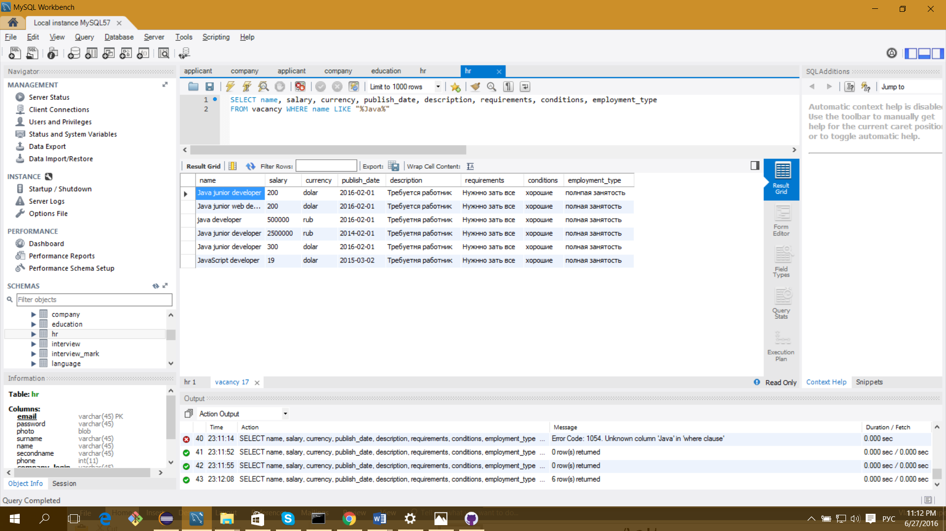

Вывести среднюю з.п. по предлагаемым вакансиям типа „java developer” в долларах

SELECT avg(salary) as averege_salary

FROM vacancy

WHERE

name LIKE "%ava %"

and currency="dolar"

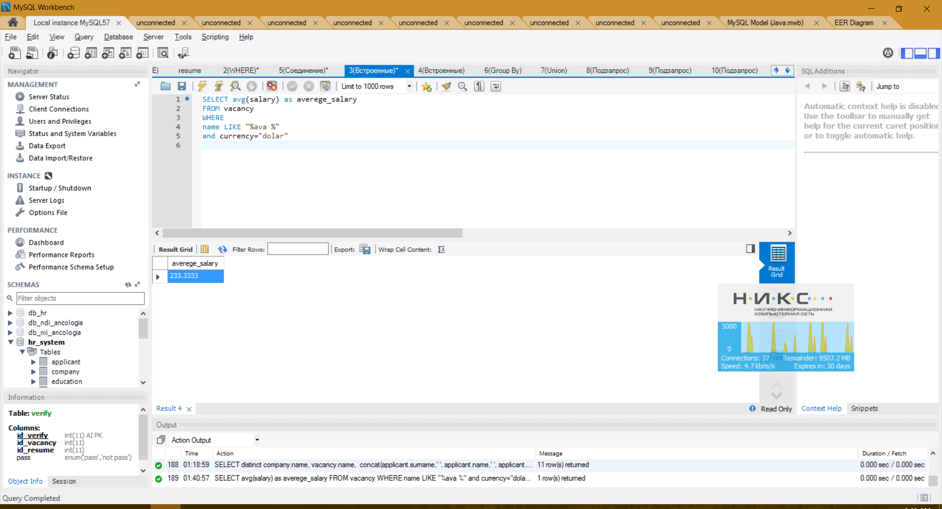

Вывести ФИО соискателей и названия вакансий, оставленные компанией „Iknow”, на которые соискатели отправили заявку.

SELECT vacancy.name, concat(applicant.surname,' ', applicant.name,' ', applicant.secondName) as fio

FROM applicant join resume ON applicant.email = resume.email

join verify on resume.id_resume = verify.id_resume

join vacancy on vacancy.id_vacancy = verify.id_vacancy

join hr on hr.email = vacancy.email

join company on company.company_login = hr.company_login

WHERE

company.name = "Iknow"

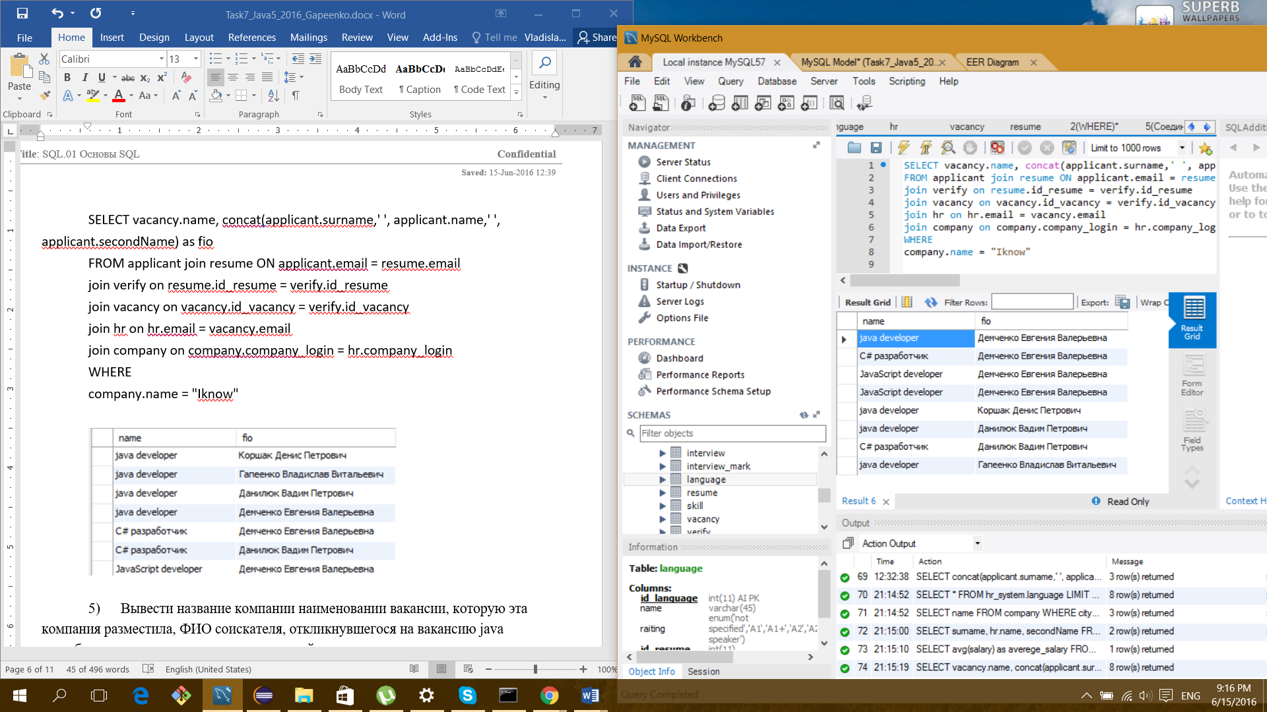

Вывести название компании наименовании вакансии, которую эта компания разместила, ФИО соискателя, откликнувшегося на вакансию java разработчика и его уровень владения английским языком.

SELECT distinct

company.name,

vacancy.name,

concat(applicant.surname,' ', applicant.name,' ', applicant.secondName) as fio,

language.name,

language.raiting

FROM applicant join resume ON applicant.email = resume.email

join language on resume.id_resume = language.id_resume

join verify on resume.id_resume = verify.id_resume

join vacancy on vacancy.id_vacancy = verify.id_vacancy

join hr on hr.email = vacancy.email

join company on company.company_login = hr.company_login

WHERE

vacancy.name LIKE "%ava %" and language.name Like "%nglish"

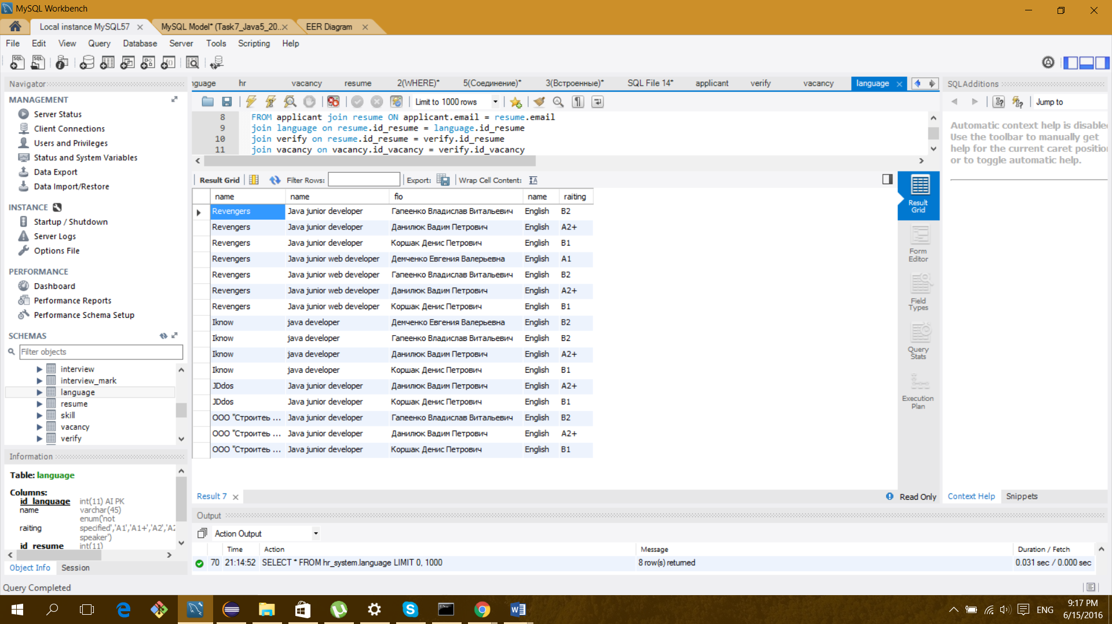

Выбрать ФИО соискателя, название вакансии, день и время проведения всех собеседований в текущем месяце, которые проводила компания „Revengers”.

SELECT vac.name,

extract(DAY from i.date_begin) as day,

extract(HOUR_MINUTE from i.date_begin) as hour,

concat(a.surname,' ', a.name,' ', a.secondName) as fio,

i.type

FROM applicant as a join resume as r ON a.email = r.email

join verify as v

on r.id_resume = v.id_resume

join vacancy as vac

on vac.id_vacancy = v.id_vacancy

join hr

on hr.email = vac.email

join company as c

on c.company_login = hr.company_login

join interview as i

on v.id_verify = i.id_verify

WHERE

c.name = "Revengers" and MONTH(date_begin) = MONTH(NOW()) AND YEAR(date_begin) = YEAR(NOW())

group by

day,hour

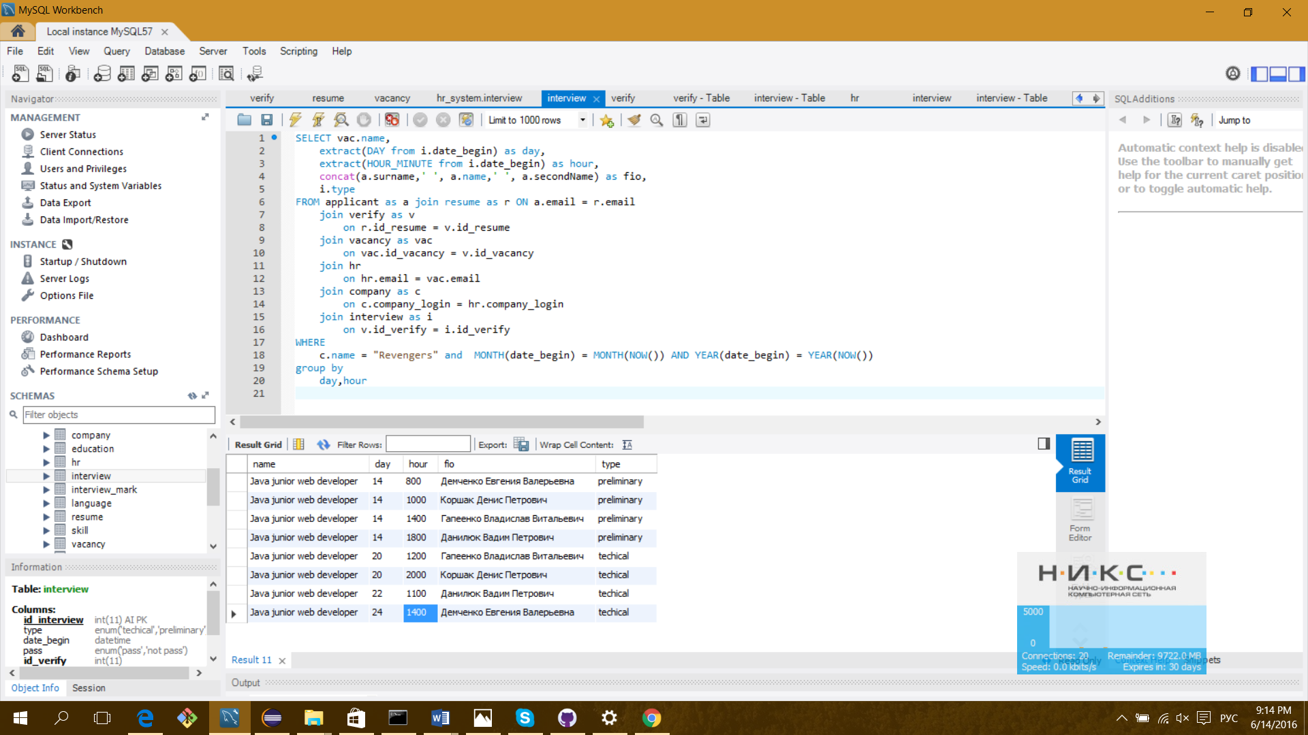

Выбрать вакансии предлагающие зарплату > 120 долларов и выше 2400000 белорусских рублей, так же вывести предлагаемую ими зарплату в долларах и рублях

SELECT vacancy.name, salary, currency

FROM vacancy

WHERE salary>120 and currency="dolar"

UNION

SELECT vacancy.name, salary, currency

FROM vacancy

WHERE salary>2400000 and currency="rub"

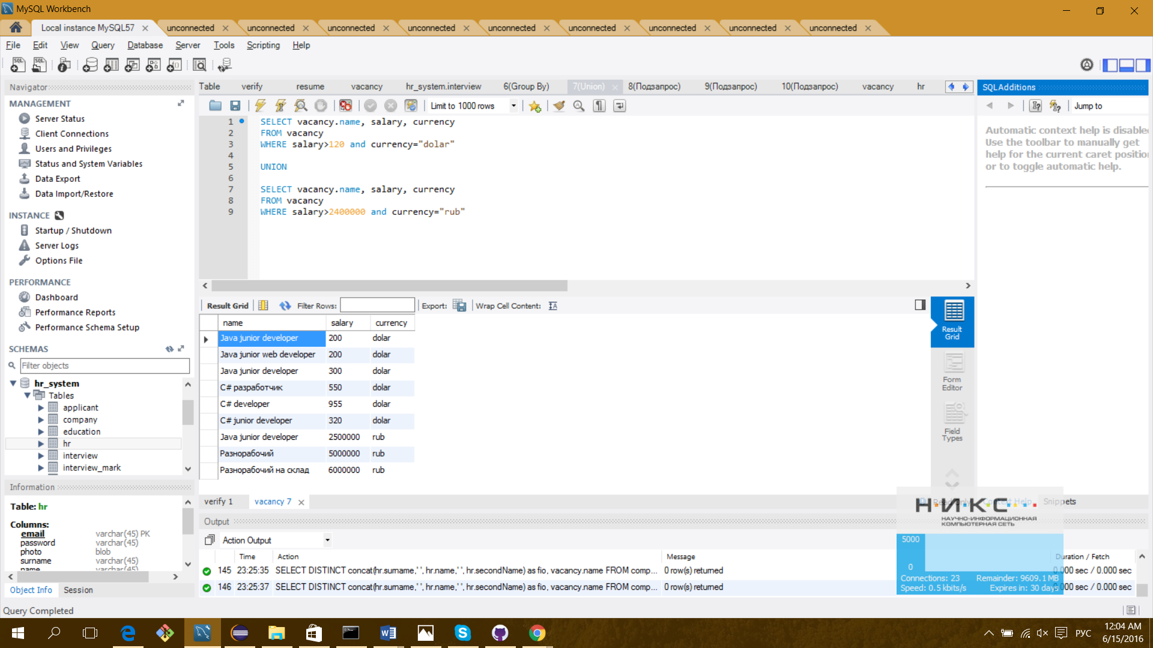

Найти самую высокооплачиваемую работу в белорусских рублях

SELECT vacancy.name , salary

FROM vacancy

WHERE salary = ( SELECT Max(salary) from vacancy)

and currency = "rub"

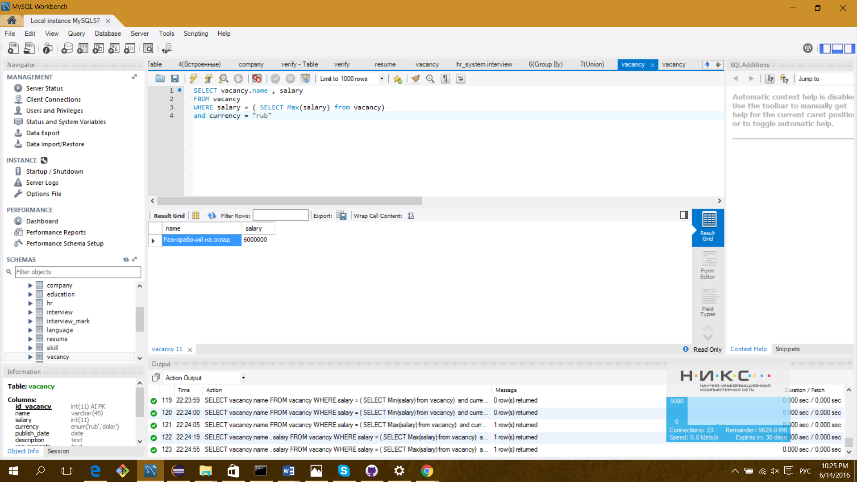

Выбрать названия компаний предоставляющие вакансии по C#

SELECT company.name

FROM company join hr on company.company_login = hr.company_login

join vacancy on hr.email = vacancy.email

WHERE vacancy.name IN (SELECT vacancy.name FROM vacancy WHERE vacancy.name LIKE "C#%")

